Games Programming 2 Coursework

Ivan Konstantinov

Student ID: S1829087

*I confirm that the code contained in this file (other than that provided or authorised) is all my own work and has not been submitted elsewhere in fulfilment of this or any other award*.

Contents

1. Overview 2

2. Display 2

3. Camera 3

4. Mesh 3

5. Shader 4

6. Textures 5

7. Transform 6

8. MainGame 6

9. Extension 6

10. References 6

# Overview

My coursework is to create 3D environment using OpenGL and C++. It should contain 3 different models, with their textures. I have decided to create a scene where a wolf must catch the cat with user control. The third model is a moon for decoration at the top right corner. After the cat has been caught, a collision sound is triggered. I have added lightning and user control of the model via input.

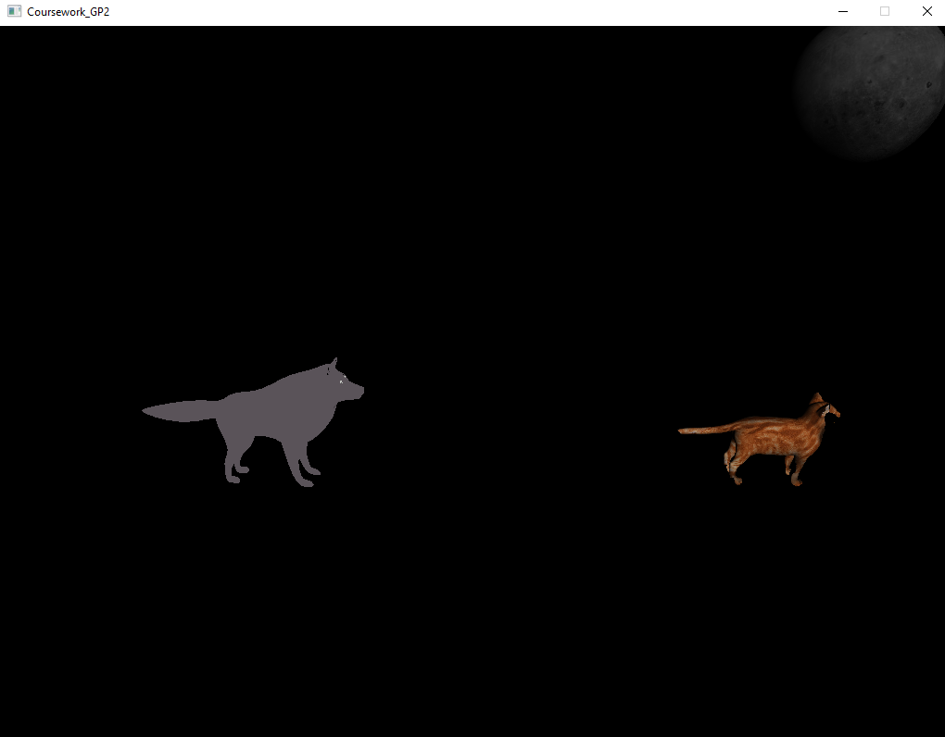

Figure 1.1

# Display

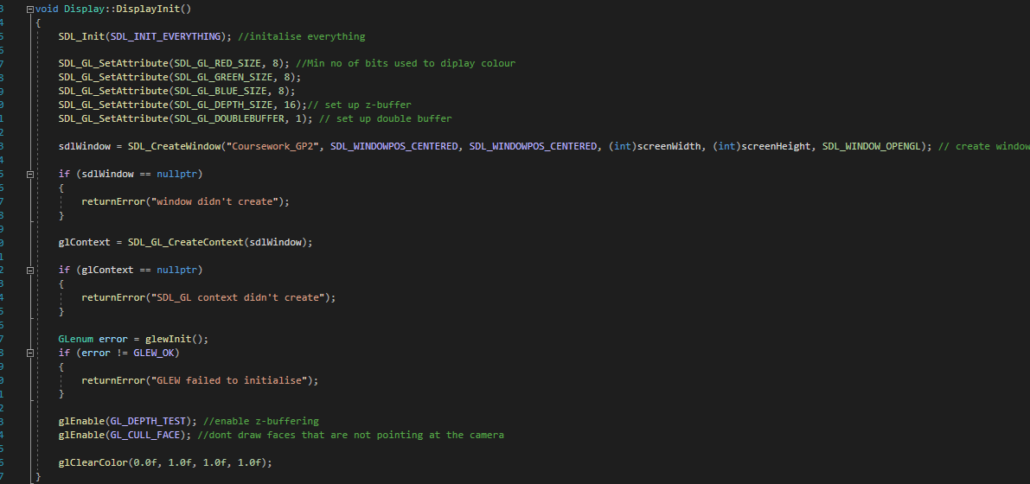

Figure 2.1

In Display.cpp the constructor sets the pointer to the display to be equal to NULL, screenWidth to be 1024 and screenHeight to be 768. In the destructor, the window and the glContext are being destroyed after the program is closed.

In the returnError() function we are looking for an error and if any is found it is being returned to the console. In the swapBuffer() function the SDL_GL_SwapWindow (sdlWindow) is being used to swap between the display buffer and the draw buffer on which the GPU is drawing. In clearDisplay() function the Display is cleared and set to a specific color variable.

In the DisplayInit() function SDL is being initialized and a window is being created using SDL_CreateWindow with the required parameters. We also have some getters to get the screen Width and Height.

# Camera

Figure 3.1

The camera struct is created and it is responsible for the camera position and movement. In InitializeCamera(), camera position, forward, up, and projections are being set. In getPos() the function returns the position of the camera when it is called. The projection is a glm::mat4 variable and the position, forward, and up are glm::vec3.

# Mesh

Mesh class is used to generate the mesh of the model by using its vertices.

The init() function initializes the mesh. The initModel() function draws the mesh by using the glGenVertexArrays, glBindVertexArray, glGenBuffers ,

glBindBuffer, glBufferData, glEnableVertexAttribArray functions that are defined in OpenGL and they are responsible for generating a vertex array and moving the data which is in there to the GPU instead of the CPU. In the loadModel() function a model is being loaded by giving this method the name of the model obj file. The draw() function draws the mesh every second.

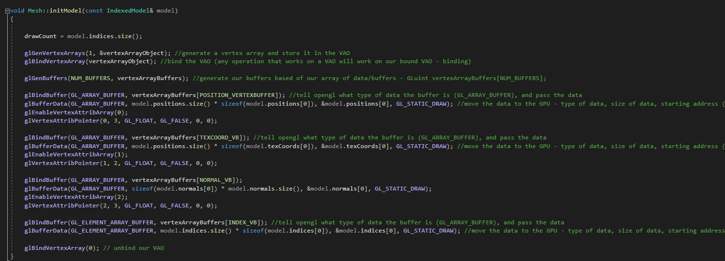

Figure 4.1

# Shader

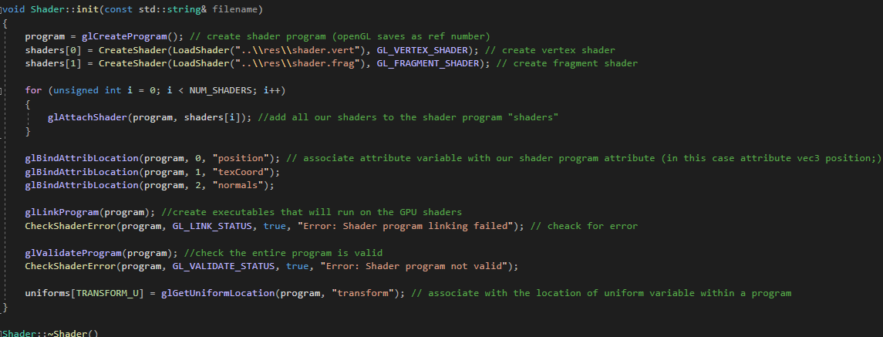

Figure 5.1

In Shader Class, the vertex and the fragment shader files are added to the program. Then we check if there are any errors with that shaders implementation. In the destructor of that class, all shaders are being deleted.

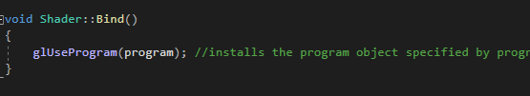

Figure 5.2

In Bind(), Installs a program as part of current rendering state. In the Update() the shader is being updated each frame. In CreateShader() , it takes the shader text and returns shader for the program to use., There are some error checks, to assure that the shader is created correctly. The LoadShadder() takes string reference of file name and it loads the shader from that file.

# Textures

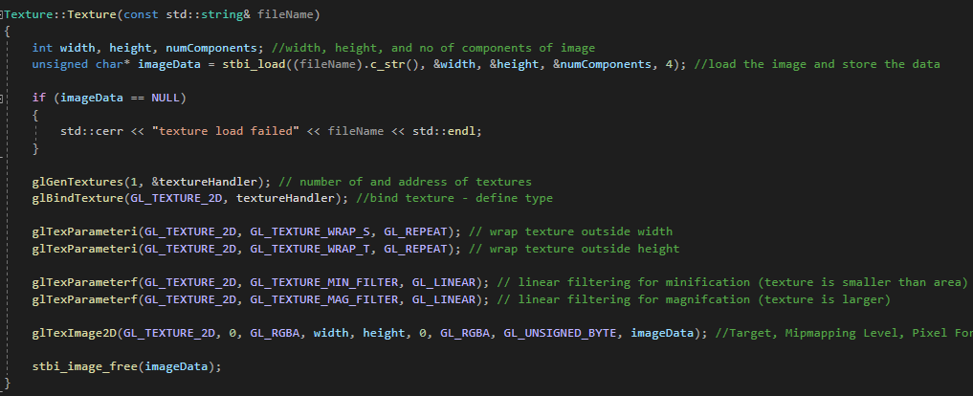

Figure 6.1

In Textures.cpp we have constructor, destructor and a Bind() function. The constructor has stbi() load function that takes filename and loads the texture file into the program. Then we give to glGenTextures, the address of our textures. Then we bind the texture to our texture handler and we specify how much is the minification and magnification of the texture. Then we load the Texture to the program using glTexImage2D(). In the desctructor we delete the reference to the texture.

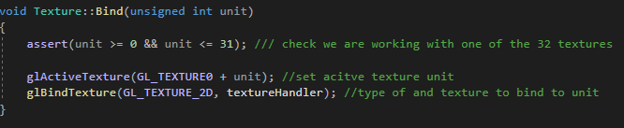

Figure 6.2

In the Bind() function, we check if we are working with 1 of the 32 textures and then we set the following texture to active and we bind the texture to the texture handler.

# Transform

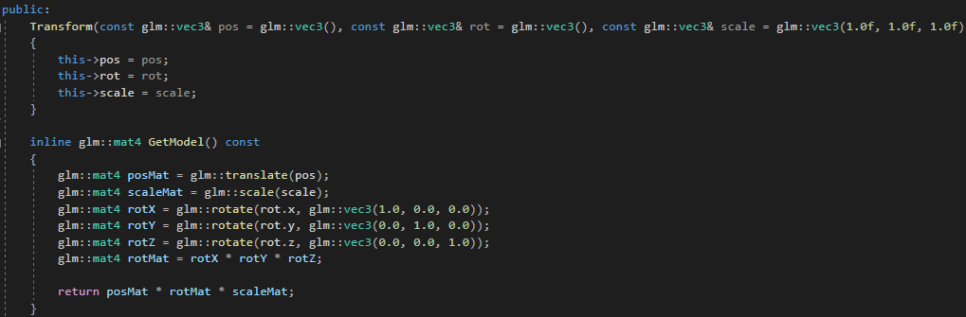

Figure 7.1

In Transform.h the models that are already in the program are getting their transforms, or in other words positions within the world space. The constructor is setting their positions. The GetModel() function is working like a getter, it let us to take the exact position multiplied by the model's rotation and the scale of the model. This tells us exactly where is our model positioned in the game world and in what direction it is looking at and how big it is. In transform.h we also have setters and getters for position.x, position.y, position.z, rotation and scale in order to be able to access and change that value out of transform.h

# MainGame

This is the file responsible for the whole gameplay of the game. The first thing we do in it, is to give all the meshes transforms within the game space. After that we have the MainGame() constructor which is creating mesh() for each mesh that we have in the game. In the run function, the game calls initSystems ()and gameLoop(). InitSystems() creates display, initializes it, loads all the audio, sounds effect, mesh models and initializes the camera and the shader. Also, there is a variable called counter which is responsible for the movement of the characters.. In the gameLoop() function we have ProcessInput(), drawGame(), collisiondetection function and playAudio(). The ProcessInput checks If an event has occurred which in our case will be SDL_QUIT which quits the whole program or SDL_KEYDOWN, which looks if the specific button was pressed by the user if it was, it does the following actions, which in our case, let’s the wolf to transform its position and chase the cat. In the collision, we create spheres around all meshes, and then with the radius and some mathematics we check if the two different mesh spheres have collided, and if they have a specific voice is played. In the drawgame() function Texture references are created and the texture jpg are added by their file name to the following references. Then we Bind the shader, update the shader, draw the mesh, set mesh rotation and scale and update the sphere data for the collision sphere for each mesh, all this is happening on the drawBuffer, once the function is done, the program swaps the buffer with the display one, and starts drawing the next scene. All that functions are used constantly within the gameLoop().

# Extension

For my extension material, I decided to add, user input controller and lightning to the game. For the user input, I used the SDL_PollEvent() function which lets me track if a certain event has happened, and therefore I can check if a specific key on the keyboard was pressed or released, with that I have set W,A,S,D to be the movement keys for the wolf. I am moving the wolf by setting its mesh transform position using the SetPos() function with glm::vec3 formed from the x.position, y. position, and z.position added to counter, depending on what movement I want to get.

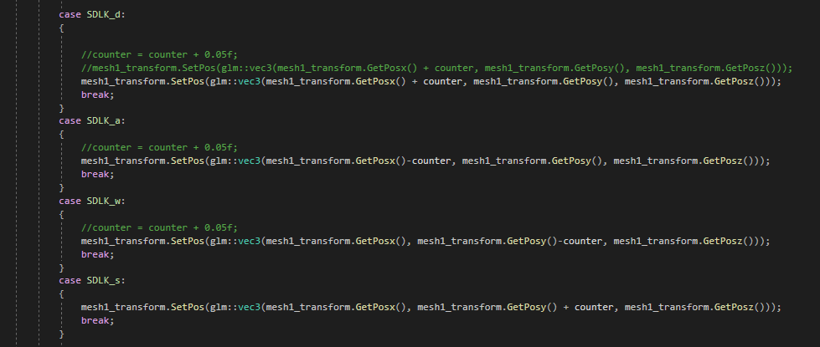

Figure 9.1

For the lightning, I am using Lambertian Lightning. In the Fragment Shader I set the gl_FragColor to be equal to texture2D(diffuse, texCoord0)* clamp(dot(-vec3(0,0,1), normal0), 0.0, 1.0). Which takes our texture and multiplies it by a certain value which is between 0 and 1 and this gives us the lightning

# References

I have used <https://youtu.be/ftiKrP3gW3k?list=PLEETnX-uPtBXT9T-hD0Bj31DSnwio-ywh> for the Lambertian lighting tutorial.

The moon: <https://free3d.com/3d-model/realistic-moon-65166.html>

The cat: <https://free3d.com/3d-model/cat-v1--522281.html>

The wolf: <https://free3d.com/3d-model/low-poly-wolf-432873.html>

For the soundtrack, I have used the short free version of :

<https://www.playonloop.com/2015-music-loops/countering-evil/>

The textures of the moon and the cat are coming with their models and the wolf is using the bricks texture that was provided in the labs. The collision sound is also from the labs.

Video of the coursework:

<https://youtu.be/a3iZXcefbEA>